Theory – Formation of elements 🡪 universe mimics our brain and neurons/ synaptic space…

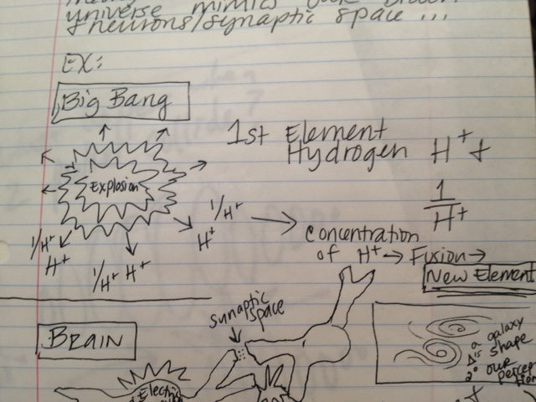

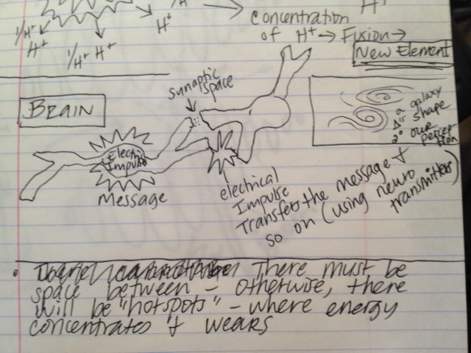

There must be space between - otherwise, there will be “hotspots” – where energy concentrates and weakens.